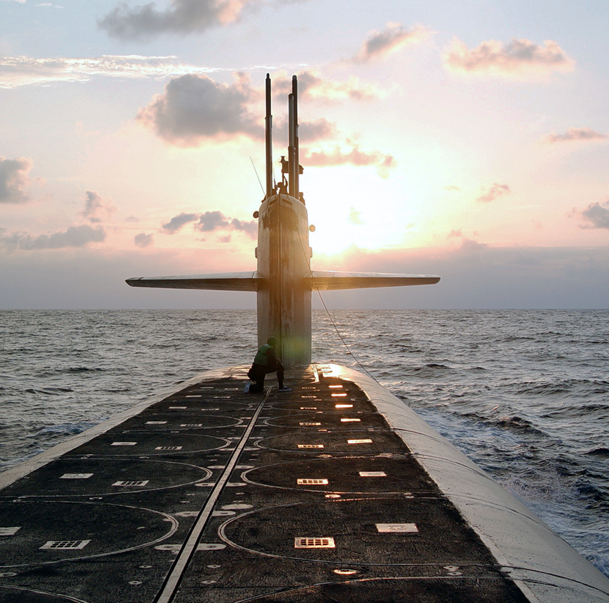

**United States Navy**

**Pseudofolliculitis Barbae (PFB)**

**Commanding Officer’s Toolkit**

This guide is intended as a supplement to the *BUPERS INSTRUCTION 1000.22C (BUPERSINST 1000.22): Management of Navy Uniformed Personnel Diagnosed with Pseudofolliculitis Barbae (PFB)*. The Commanding Officer’s (CO) PFB Toolkit addresses many topics to assist in understanding medical and policy terms and requirements, and related issues which may not be repeated in BUPERSINST 1000.22C. This guide is not all-encompassing. Should COs have questions or discover situations which are not adequately addressed, they are encouraged to contact the Bureau of Medicine or the Bureau of Naval Personnel listed at the end of this guide for policy assistance.

COs should use this opportunity to review their local standards of personal safety and readiness to ensure that they provide adequate guidance in relevant areas, apply uniformly to all personnel, and promote an environment of individual and unit readiness and performance. Place special emphasis during such review on the following areas: unit readiness, personnel safety, personnel accountability, local medical support and rapport, and command leadership. Standards must reflect responsibility of leaders, supervisors, and subordinate personnel to foster unit cohesion, good order and discipline, compliance with directives, and mission readiness.

COs must promote the importance of personnel safety and readiness and take action to minimize PFB associated mission and safety risks. COs must also encourage compliance of prescribed medical treatments, maintain accountability of members and supervisors and provide clear guidance and awareness of policy guidance and the command’s personnel readiness requirements.

**What is PFB?**

Pseudofolliculitis Barbae (PFB) is a common hair condition characterized by a foreign body inflammatory reaction that is caused by ingrown hairs, usually in the face and beard areas, after removal of the hair. It results from entry and penetration of the skin by the tip of the growing curved hair.

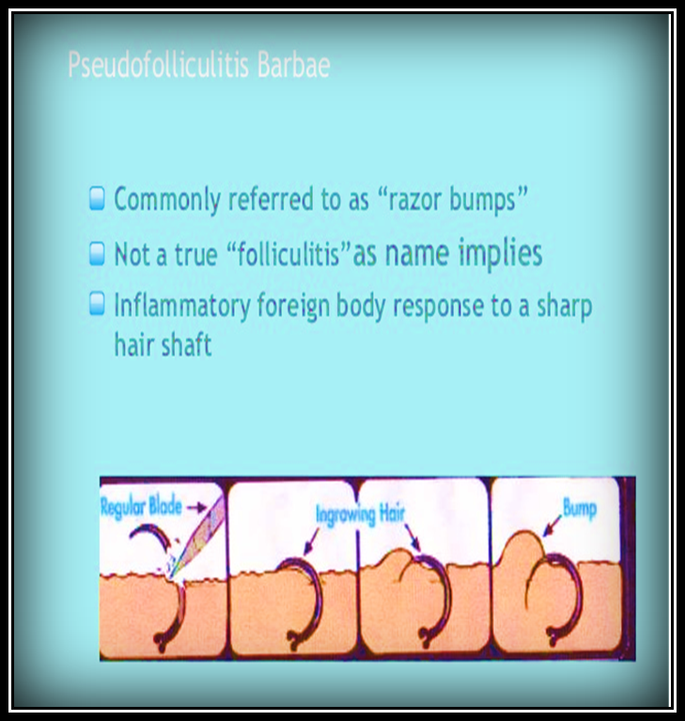

**Who gets PFB?**

Curly hair has a much higher tendency of growing back into the skin than straight or wavy hair. The PFB process is not gender or race dependent and can occur in any skin area subjected to regular shaving, plucking, waxing or other traumatic means of hair removal. PFB can occur in women including those with endocrine disorders in which beard hair growth (and thus shaving) may occur.

**Why is PFB a problem for Sailors?**

Various operational, training and maintenance environments may require the wear or utilization of breathing protection by Sailors. Facial hair that lies along the sealing area of a respirator or protective mask, such as beards, sideburns, or mustaches will interfere with respirators that rely on a tight fit to achieve maximum breathing protection. The areas of the skin, which contact the face or neck seal and nose cup seal, must be free of any hair. Sailors with untreated/unmanaged PFB are subject to safety risks due to facial hair growth or non-smooth skin condition that prevents the proper seal and thus safe function of respiratory protective masks. Refer to ALSAFE 18/008.

The medical management of PFB often necessitates the wearing of a ¼-beard for up to 4 weeks or more during some phase of treatment. Provisions to allow for beard growth in support of PFB treatments when operational, training and maintenance schedules can support is recommended.

When tightly curved hairs are observed to re-enter the skin and create irritated papules, the diagnosis of PFB can be made. Irritation related to shaving without hair re-entry can be treated according to this protocol as well. Other conditions that inhibit shaving, such as severe acne, may also warrant a temporary discontinuation of daily shaving while proper medical treatment is pursued.

Many different treatments exist for PFB. Over-the-counter (OTC) treatments, including chemical depilatories, may be useful and can be used by Service members without medical supervision. Prescription regimens may be more effective in some cases and can be used without previous trial of OTC treatment.

Treatment Approach 1 – Medical Treatment with Grooming Modifications (Mild to Moderate PFB)

This treatment approach consists of the combined use of: application of medicated creams to make hairs more shaveable; shaving with gentle equipment; and shaving techniques to minimize this risk of irritation and hair re-entry into the skin.

Service members using this approach should be given a prescription of either a topical retinoid or eflornithine 13.9 % (if available) and a temporary waiver of facial hair standards for up to 60 days. The medications should be used for the full 60 days before shaving is attempted, and should be used continuously after successful shaving is resumed. Topical retinoids work by softening the hair and reducing the skin’s tendency to overgrow penetrating hairs. They include tretinoin 0.05% cream (NSN 6505-01-044-9389), tretinoin 0.1% cream (NSN 6505-01-044-9388) and adapalene 0.1% cream (NSN 6505-01-564-8033). They are applied in a thin film to the beard area once each night. During the first weeks of use, they cause mild irritation which usually resolves with continued use. Excessive irritation may require using a weaker retinoid or decreasing use to every other night. As an alternative to topical retinoids, eflornithine 13.9 % could be prescribed if available. This cream would be applied to the beard area twice daily. It acts as an inhibitor of hair growth and results in thinner, weaker hairs, less likely to cause papules.

After 60 days using these products, shaving can be attempted with a PFB razor with foil guard, a multi-blade razor with lubricating strips, or with an electric razor.

Before shaving, water soften the beard first with a hot wet washcloth applied for 5 minutes. This makes hairs easier to cut and more blunt-tipped after cutting. Apply a lubricating shaving gel for an additional 5 minutes. Shave with the grain of the beard. Do not stretch the skin or press firmly against the skin. Use only one stroke over each area of the beard. Always use a sharp razor, replacing often.

If using an electric razor, set hair length to avoid too close a shave. Soften the beard with electric razor pre-shave products. Shave with the grain of the beard. Do not stretch the skin or press firmly against the skin. Avoid multiple strokes in the same area. Do not press razor head hard against the skin.

A soothing aftershave cream should be applied whether a PFB razor or an electric razor is used. Health Care Providers may also consider prescribing hydrocortisone cream for use after shaving if needed.

Treatment Approach 2 – Laser Hair Reduction with Grooming Modifications (Moderate to Severe PFB)

Where available, laser hair reduction is the most reliable approach allowing a return to grooming standards. This is an appropriate treatment for mild to severe cases of PFB. In this procedure, light energy is absorbed by the hairs within the skin and is transformed into heat. Heat injury to the follicles reduces the number, size, and strength of hairs. A series of at least 3 treatments is usually needed, with 30-45 days between treatments. This procedure is usually only available at military medical treatment facilities with a dermatology department.

Service members choosing this approach will be referred to a military dermatologist. Grooming modifications of facial hair standards should be granted per the dermatologist recommendation in preparation for treatment. Service members should be aware that hair reduction in treated areas may be permanent and shaving is still required after treatment is complete. White, red, and blonde facial hair cannot be effectively treated with this approach.

Continued Care:

Once the prescribed technique is in use, the Service member should follow up with the health care provider to evaluate effectiveness. Follow up should usually occur within 2-3 weeks after shaving is resumed.

Complete relief of symptoms is rare, and treatment can be counted successful when symptoms are improved enough to allow comfortable shaving. Service members who have achieved control of their PFB or other shave related skin irritation may have occasional future flares of the condition. Laser treated patients sometimes have recurrent papules years after treatment is complete. Service members with recurrent symptoms may need to repeat their previous treatment approach or try another.

Refer to Figure 1-1 for the PFB Treatment process flowchart and Figure 1-2 for the Treatment Approach process.



Health Care Providers (HCPs) must:

* Diagnose and treat the cause of facial irritation according to the guidelines in BUPERSINST 1000.22, Management of Navy Uniformed Personnel Diagnosed with Pseudofolliculitis Barbae (PFB).
* Document prescribed treatment regimen on NAVPERS form 1000/1 (Rev. ), Pseudofolliculitis Barbae (PFB) Evaluation/Disposition, and add to the Sailor’s medical record.
* Refer the Service member to a dermatologist when appropriate.
* Educate Sailors and command leadership about the condition and treatment plans.
* Upon conclusion of the prescribed treatment period, complete the “Evaluation by Health Care Provider” section of NAVPERS form 1000/1, indicate result of findings and recommendation by checking the appropriate block and forward a copy to the Sailor’s CO. In cases of treatment non-response, treatment interruptions, and treatment failures, provide a recommendation to the CO for re-evaluation and re-treatment, alternative shaving regimen, or administrative action using NAVPERS form 1000/1.
* Conduct annual re-evaluation of PFB Sailors determined non-responsive to both medical and laser treatments. Determine susceptibility for continued PFB treatment and determination to return to normal grooming standards. Document findings in Sailor’s medical record.

Commanding Officers of Sailors undergoing treatment for PFB must:

* When operational, training, maintenance or duty assignments permit, implement the recommendations of the health care provider as documented on NAVPERS form 1000/1. During periods of prescribed non-shaving, the Sailor shall not be required nor permitted to shave. Interrupting the treatment regimen will result in prolonging the treatment process and require medical re-evaluation before the treatment can resume. When operational, training or maintenance requirements prohibit implementing PFB treatment regimens, direct Sailor to shave as required.
* Counsel the Sailor on the requirement to comply with the prescribed treatment protocols and the potential administrative impacts to continued service eligibility if they fail to comply as directed. Document counseling on NAVPERS 1070/613.
* Enforce professional appearance and other uniform standards during periods of waiver of facial hair standards, ensuring facial hair naturally stands off the skin no more than 1/4 of an inch. Facial hair is to be of uniform length, free of sculpted styling.
* Provide allowances for Service members diagnosed with PFB who show scant facial hair growth (5 o’clock shadow) due to their prescribed control techniques such as avoiding too close a shave.
* Establish grooming requirements that facilitate personnel safety and reasonable approach to PFB management.
* When a prescribed regimen fails to adequately control PFB, direct the Sailor to the health care provider for re-evaluation and new treatment regimen. Contact the health care provider as necessary to determine the cause of the treatment failure and recommended new treatment regimen.
  + A CO’s waiver authority will not extend beyond detachment of the CO or the detachment of the Sailor from the command.
  + Unavailability of any prescribed treatment (such as laser treatment) or medication will not be grounds for administrative actions or ineligibility for continued service provided the Service member has demonstrated good faith in attempting to resolve their PFB disorder.
  + Direct modified shaving routine for PFB Sailors determined non-responsive to medical and laser treatments (facial hair not to exceed ¼-inch between shaving periods). Ensure Sailor participates in annual PFB re-evaluations to determine susceptibility for PFB treatment and determination to return to normal grooming standards.

**Document Counseling on NAVPERS 1070/613**

* Ensure you and the Sailor understand:
  + the PFB diagnosis
  + the recommended prescribed treatment regimen
  + the importance of complying with the treatment regimen
  + PFB condition is not considered a physical disability but could be a disqualifying factor for continued naval service, potentially resulting in administrative separation
* Explain what assistance is available to the Sailor, including chain of command and medical department
* Explain shaving may be directed when operational, training, or maintenance requirements prohibit implementing PFB treatment regimens (i.e. allowing facial hair growth)
* Explain willful violation of medically prescribed and command endorsed treatment regimens is considered a UCMJ violation and is subject to administrative actions
* Have Sailor sign the Page 13 counseling, acknowledging an understanding of the above

When a treatment regimen must be interrupted due to operational or other requirements or duties that necessitate the removal of facial hair, direct the Sailor to follow-up with their HCP at the earliest opportunity. The HCP should evaluate treatment progress and formulate a new treatment regimen by completing a new NAVPERS 1000/1.

In such cases, COs may direct daily shaving until the prescribed treatment regimen can be resumed.

COs should allow such Sailors to resume their treatment regimen as soon as possible after the conclusion of the operational or other requirements or duties and facilitate follow-up with the Sailor’s health care provider as soon as possible.

**If I have PFB and a “no shave chit,” am I now required to shave?**

Permanent shaving waivers are not authorized. Sailors diagnosed with PFB who were previously issued a “permanent no-shaving waiver” must undergo re-evaluation by an authorized health care provider, be prescribed an approved PFB treatment regimen and obtain a temporary grooming modification routine from their commanding officer by following the guidelines and procedures outlined in BUPERSINST 1000.22. Re-evaluation for those Sailors currently on “no shave” waivers must occur within 6 months of the date of publication of BUPERSINST 1000.22 unless the Sailor is deployed or assigned to a region where a medical evaluation and treatment is not available. In such cases, the member will follow the instructions of the unit commanding officer regarding the need to remove facial hair.

**What should I do if I think I have PFB?**

See your health care provider. You can also try the Over-the-Counter treatments described in BUPERSINST 1000.22, encl (1).

**What medical representative should I seek to be evaluated or treated?**

Start with your primary care provider or Independent Duty Corpsman. If the condition is severe or not responsive to topical treatments, he or she will refer you to a military dermatologist.

**Is PFB a disabling condition?**

Per DoDI 6130.03, PFB is a disqualifying, but waiverable condition for initial appointment, enlistment or induction into military service. Continued military service for Sailors diagnosed with PFB, beyond their initial enlistment or appointment, is dependent upon medical diagnoses, active treatment or condition resolution, full compliance of prescribed treatment regimens by the Service-member and recommendation for retention by health care providers and commanding officers.

**Does PFB qualify for a medical board review?**

No. PFB treatment failures that prohibit Sailors from shaving, performing assigned duties or deploying as determined by the health care provider and unit commanding officer may result in administrative action in accordance with MILPERSMAN 1900-120. The determination of such actions will be documented on NAVPERS 1070/613 and placed in the Sailor’s service record.

**Is there a limit on the number of treatments I can receive?**

No. Service members who have achieved control of their PFB or other shave related skin irritation may have occasional future flares of the condition. Laser treated patients sometimes have recurrent papules years after treatment is complete. Service members with recurrent symptoms may need to repeat their previous treatment approach or try another.

**How long are the treatments?**

Up to a maximum of 60 days for each cycle. During that time, facial hair will be trimmed to stand no more than 1/4 inch off the skin. Prescribed medications and instructions during that time period will be documented by the health care provider on NAVPERS 1000/1, PFB Evaluation/Disposition. After the treatment period, the Sailor should follow-up with the health care provider, usually within 2-3 weeks after shaving is resumed.

**Are there risks associated with treatments?**

The health care provider will counsel the Sailor on the potential adverse effects of the selected treatment regimen. Sailors should be aware that laser hair reduction may be permanent.

**Why the policy change?**

Sailor Safety and Readiness. The recent Naval Safety Center’s report on Face Seal Guidance prompted a review of the current PFB management policy BUPERSINST 1000.22B. The review determined that BUPERSINST 1000.22B assumed too much risk for Sailors and their shipmates by allowing a permanent no-shave waiver. All Sailors must be able to properly wear respiratory protective masks and equipment. Facial hair and non-smooth skin resulting from PFB prevents the proper seal for breathing protection devices and reduces the likelihood of safe and effective performance. Such conditions have a direct and unacceptable impact on personnel safety and constitute a risk to mission and risk to force.

**Does this policy apply to me if I’m not assigned to an operational, training and maintenance environment that may require the wear of a respirator or breathing equipment?**

Yes. It is the responsibility of every Sailor in every naval environment to maintain personal readiness and safety. Navy grooming standards and requirements as stated in NAVPERS 15665I and BUPERSINST 1000.22C, are aligned in support of achieving and maintaining personal readiness and safety regardless of assignment and duties. An exception to policy may be granted for Sailors requesting a religious accommodation that allows facial hair (1/4 inch beard).

Reserve Component (RC) Sailors diagnosed with PFB and not on active duty orders are required to obtain treatment through their civilian primary health care provider or TRICARE provider if enrolled. RC Sailors on active duty may seek treatment from military treatment facilities or their military health care provider. OPNAV N1 is working with BUMED to establish a waiver that will authorize RC Sailors to obtain PFB evaluations and treatments via the military health care system regardless of their active duty status. A future NAVADMIN will announce the availability of the waiver when all details have been finalized and support systems are in place.

**DoD Instructions**

DoDI 6130.03

**MILPERSMAN Instructions**

MILPERSMAN 1900-120

**ALSAFE Messages**

ALSAFE MESSAGE 18/008, 26 NOVEMBER 2018

**OPNAV Instructions**

OPNAVINST 5100.19E

OPNAVINST 5100.23G

**NAVPERS Instructions**

NAVPERS 15665I (Navy Uniform Regulations)